**ACTIVITY 2**

1. Open index.html on **Chrome**
2. Open the “**Console**” tab of the developer’s tools (Ctrl + shift + I)

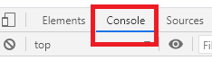

1. Execute each instruction on console, and try to understand what it does:

document.getElementById("book-list")

document.getElementById("add-book")

document.getElementsByClassName("delete")

document.querySelector("#book-list")

document.querySelector("#book-list ul")

document.querySelector("#book-list ul li")

| **INSTRUCTION** | **YOUR DEFINITION** |
| --- | --- |
| getElementById |  |
| getElementsByClassName |  |
| querySelector |  |